In-Depth Research Report on Insecure Authentication and Authorization in Mobile VAPT

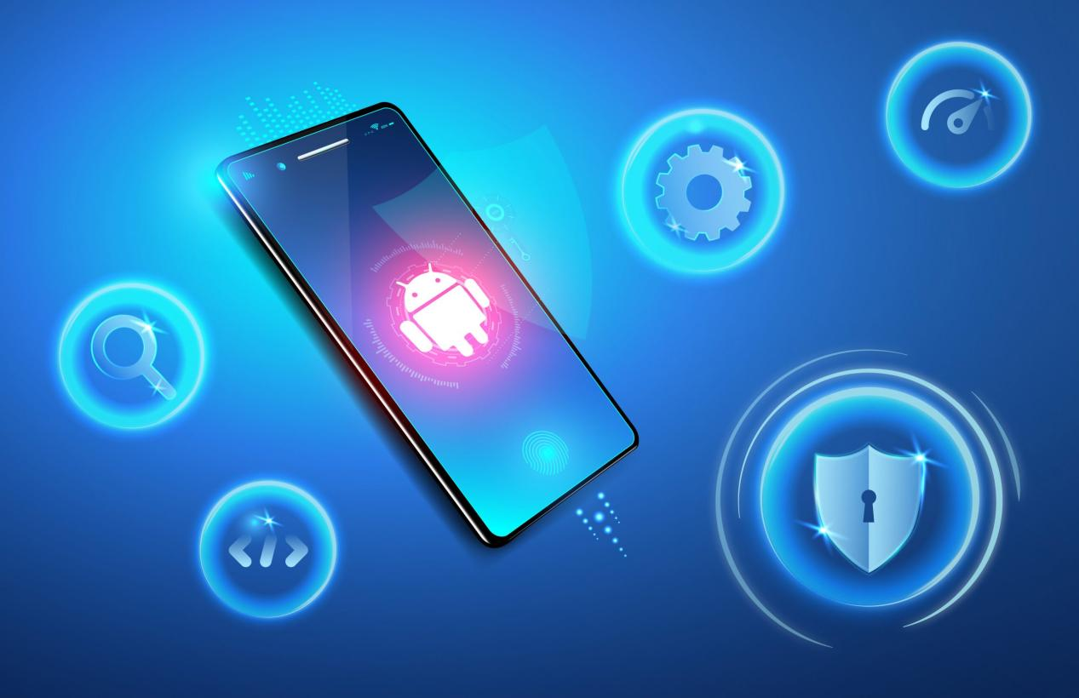

1. Introduction
Overview of Authentication and Authorization:
Authentication ensures a user's identity is valid, while authorization governs what resources an authenticated user can access. Insecure implementations of these mechanisms can expose mobile applications to severe vulnerabilities.
  - Example: A banking app that fails to validate user tokens might allow unauthorized access to sensitive financial information.
Importance in Mobile VAPT:
The rising dependency on mobile applications demands robust security mechanisms. Vulnerabilities in authentication or authorization are commonly exploited to gain unauthorized access to sensitive data or perform malicious actions.

2. What is Insecure Authentication and Authorization?

Insecure Authentication:
- Occurs when mechanisms to verify user identity are poorly implemented, allowing attackers to impersonate legitimate users.
- Example: Weak password enforcement in a mobile app that accepts "12345" as a valid password.

Insecure Authorization:
- Arises when an application fails to enforce proper access controls, allowing users to perform actions beyond their intended permissions.
- Example: Improper implementation of role-based access controls where regular users can access administrative features.

3. Methods of Insecure Authentication in Mobile VAPT
- Weak Password Policies:
  - Lack of complexity requirements (e.g., length, special characters).
  - Acceptance of commonly used passwords.
  - Example: An e-commerce app allowing "password123" as a valid password.
- Improper Multi-Factor Authentication (MFA):
  - Flawed implementations bypassed by intercepting or reusing one-time passwords (OTPs).
  - Example: OTPs sent over SMS being intercepted via SIM swapping attacks.
- Credential Storage Issues:
  - Storing passwords, session tokens, or API keys in plaintext files or local storage.
  - Example: Hardcoded credentials in an Android app’s strings.xml file.
- Session Management Flaws:
  - Lack of proper session expiration or secure cookie settings.
  - Example: Reuse of session cookies from previous sessions, enabling session hijacking.
- Biometric Authentication Weaknesses:
  - Vulnerabilities allowing attackers to bypass fingerprint or facial recognition.
  - Example: Using a high-quality photo to bypass face unlock features.
- Hardcoded Credentials:
  - Embedding sensitive information (e.g., admin passwords) directly in the app’s codebase.
- Insecure API Authentication:
  - Predictable API keys or insufficient validation mechanisms.
  - Example: Using a static API key for all users, which can be extracted by reverse engineering the app.

4. Methods of Insecure Authorization in Mobile VAPT
- Broken Access Controls:
  - Absence or misconfiguration of rules governing resource access.
  - Example: Users accessing admin-only APIs by guessing endpoints.
- Privilege Escalation:
  - Exploiting flaws to gain higher permissions than assigned.
  - Example: Modifying API requests to change user roles (e.g., user to admin).
- Lack of Role-Based Access Control (RBAC):
  - Failing to enforce granular permissions based on user roles.
- Insecure Direct Object References (IDOR):
  - Manipulating object references in requests to access unauthorized data.
  - Example: Changing an order ID in a query string to view another user's order details.
- Improper Endpoint Authorization:
  - APIs treating all users equally without verifying their roles.
- Exposed API Endpoints:
  - Sensitive endpoints left open to all users without validation.

5. Testing Techniques in Mobile VAPT
- Static Analysis:
  - Analyze app code to identify weak password storage, hardcoded secrets, or authentication flaws.
- Dynamic Analysis:
  - Perform real-time testing of login mechanisms, session handling, and API calls.
- Reverse Engineering:
  - Decompile the application to inspect the logic of authentication and authorization mechanisms.
- Traffic Analysis:
  - Intercept network traffic using tools like Burp Suite to identify plaintext credentials or session tokens.
- Simulated Attacks:
  - Brute force testing for weak passwords.
  - Manipulating API calls to test for IDOR or privilege escalation.

6. Case Studies and Real-World Examples
- Case Study 1:
  - An online payment app storing session tokens in plaintext was exploited, enabling attackers to hijack sessions and steal funds.
- Case Study 2:
  - A ride-hailing app with hardcoded API keys in the mobile client was reverse-engineered, allowing unauthorized API calls.

7. Mitigation Strategies

For Authentication:
- Enforce strong password policies (length, complexity, expiration).
- Use secure MFA (e.g., app-based OTPs over SMS-based OTPs).
- Implement secure storage practices (e.g., encrypted credential storage).
- Protect biometric data using tamper-proof methods.
- Rotate API keys and avoid hardcoding them.

For Authorization:
- Follow the principle of least privilege.
- Regularly audit and update access control rules.
- Use robust RBAC models.
- Validate all client-side input on the server.
- Ensure APIs enforce strict role-based checks.

8. Conclusion
- Insecure authentication and authorization are critical vulnerabilities in mobile applications.
- Proper implementation, regular testing, and continuous monitoring can significantly reduce risks.

References
- OWASP Mobile Security Project. OWASP Mobile Top 10 Security Risks. https://owasp.org/www-project-mobile-top-10
- CWE-287: Improper Authentication. MITRE. https://cwe.mitre.org/data/definitions/287.html
- CWE-306: Missing Authentication for Critical Function. MITRE. https://cwe.mitre.org/data/definitions/306.html
- OWASP API Security Top 10. https://owasp.org/www-project-api-security

